**Epicture**

Tek3 Project | Epitech { Lille }

**Documentation**

Table of contents

General information 3

Presentation of the Epicture Project 3

How to install it? 3

The Epicture Project 4

Architecture of the project 4

Explanations of the components 5

Dependencies 6

How to use it 7

Features 8

# General information

## Presentation of the Epicture Project

The Epicture project is a project for third-year students at Epitech. The purpose of this project is to create a photo sharing platform. To do this, we used React Native technology, a mobile application framework created by Facebook.

## How to install it?

To use the project, clone the repository then execute:

* npm install
* Define the ANDROID_HOME environment variable with your Android folder

for Android:

* react-native run-android

for iOS:

* cd ios && pod install && cd ..
* react-native run-ios

To build the android APK, clone the repository and execute these commands:

* npm install
* Define the ANDROID_HOME environment variable with your Android folder
* cd android && ./gradlew assembleRelease

You must have a device connected to your computer or an emulator launched to be able to run the project. After those commands, the application would appear on your device. You can now use it.

# The Epicture Project

## Architecture of the project

We have divided the project into several different folders to make it clearer. Here is the architecture of the folders that can be found in src/.

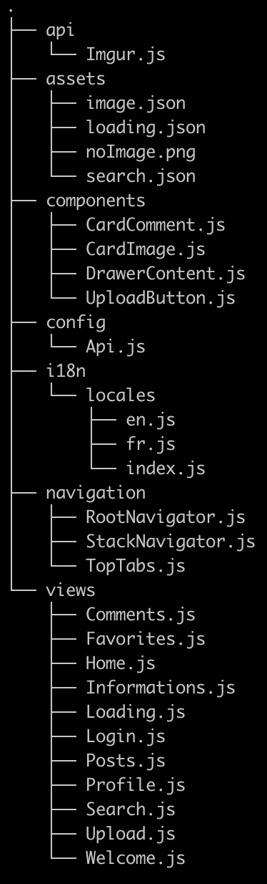

**api**: contains every function where there are Imgur API’s calls.

**assets**: contains the assets of the project, as json and png used in the application.

**components**: contains the different components shared in the

application. Don’t confuse it with the *views* folder.

**config**: contains API keys

**i18n**: contains all languages files (English, French, …)

**navigation**: contains the different main navigation pages

**views**: contains the different pages you can find while navigating in the application. In those views are called files from the *components* folder.

## Explanations of the components

This part of the documentation will allow you to understand each component and will be able to use them more easily.

|  |  |
| --- | --- |
| **Name** | **Description** |
| **CardComment** | Displays a comment card with a username and user comment |
| **CardImage** | Display a complete image card with the name of the author, the title, favs, downs and ups votes. Used in Home  View for example |
| **DrawerContent** | Displays the drawer navigator |
| **UploadButton** | Displays the upload button in Home Screen |

## Dependencies

|  |  |
| --- | --- |
| Async-storage | Asynchronous, persistent, key-value storage system for React Native |
| I18n-js | Translation system in Javascript with the JSON format |
| Lottie-view | Lottie Animation View for Vue |
| React-native-action-sheet | React native action sheet with native android |
| React-native-image-crop-picker | Select single or multiple images, with cropping option |
| React-native-vector-icons | Customizable Icons for React Native with support for NavBar/TabBar, image source and full styling |
| React-native-webview | React Native WebView component for iOS, Android, macOS, and Windows |
| React-native-video-player | React Native Video player component for iOS and Android |

## How to use it

- Log in with your IMGUR credentials on the home screen.

- You can view the HOT, TOP and VIRAL on the home screen thanks to the filter in the header.

- To add a photo to your account, click on the blue button at the bottom right of the home screen or click on "Upload" in the drawer.

- You can search the images on the Search tab with the keywords present in the title of the desired image.

- Browse your favorite images on the Profile tab then favorites. You can remove or add a favorite by clicking on the star or vote up/down by clicking on the arrows.

- Admire your profile counted your user points and many other information.

## Features

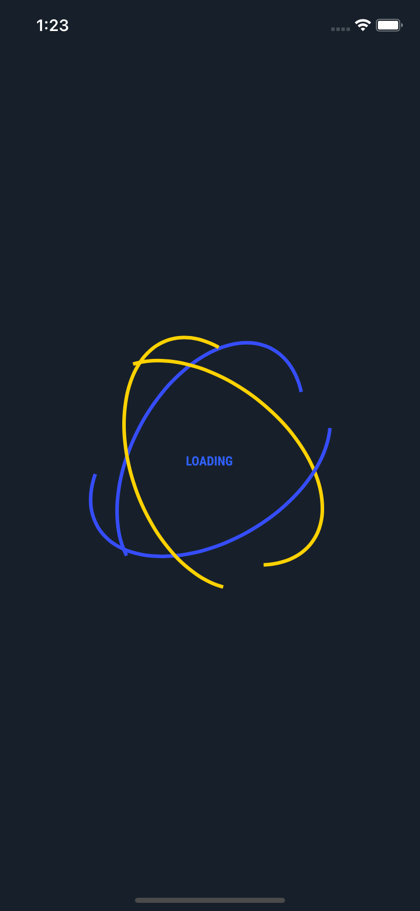

Loading screen: This is the first screen you might see. This quick screen is the loading page, it’s will check if there is the access token and username from Imgur in your cache. If there is an access token, you will be redirected to the Home Screen, otherwise, the login page will appear.

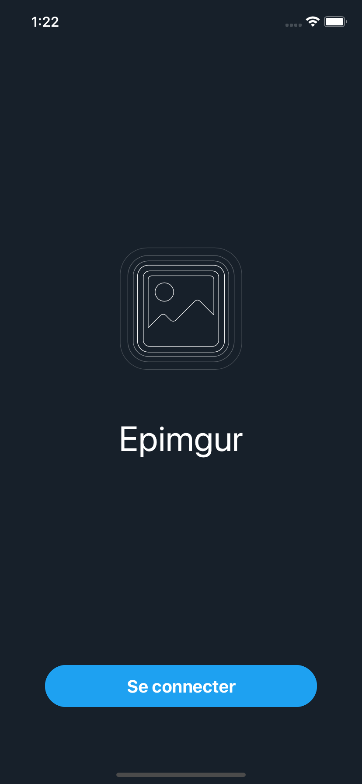

Login screen: If you are not logged in, just click on “Se connecter” if your device is in French. Then, enter your login information.

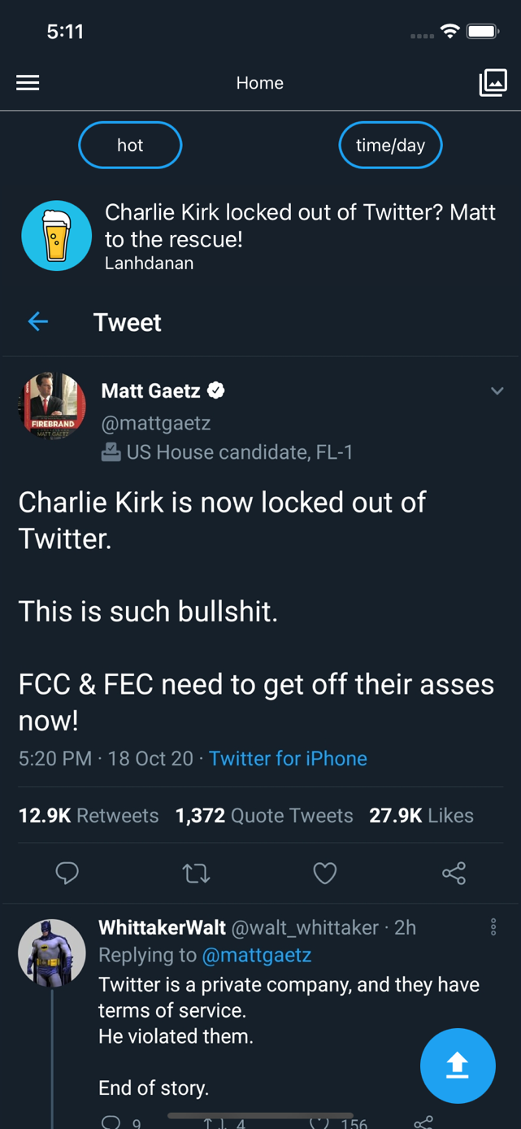

Home screen: Once logged in you will see on the home screen you will see random images coming from Imgur. On every image car, you can up/down vote, and add a image to your favorites. You can also share a post.

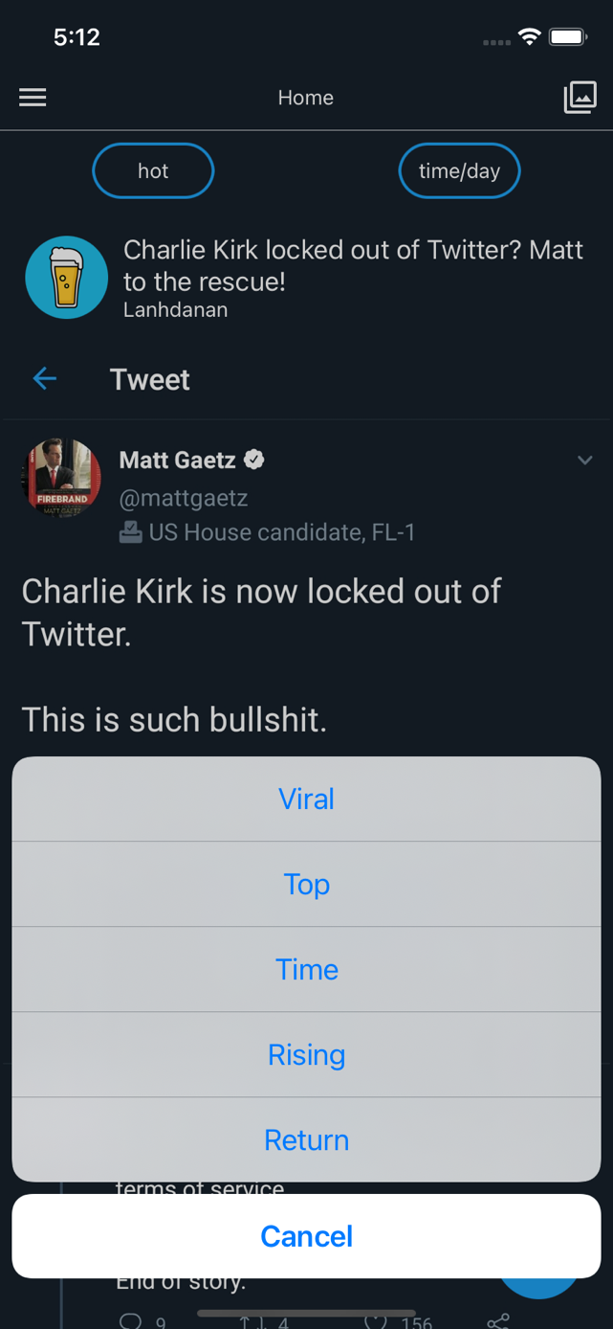

by clicking on the filter icon at the top right, you can filter the news feed

Upload screen: On the Upload screen, you can upload a picture from your library or take on from your camera. You can also take one from your camera. Then, you can resize it!

Before sending it, you can add a title and a description.

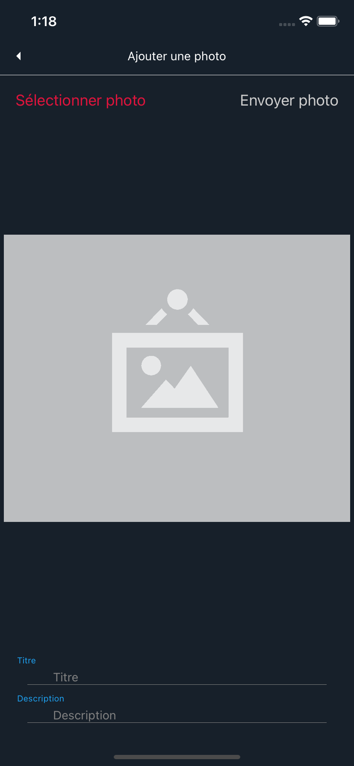

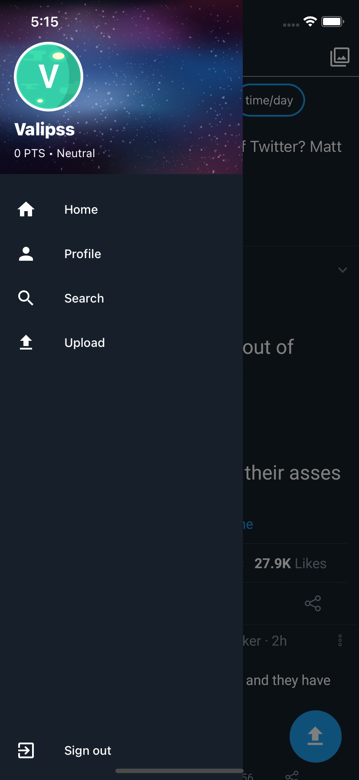

Drawer screen: You can navigate on all the application pages through the drawer navigator.

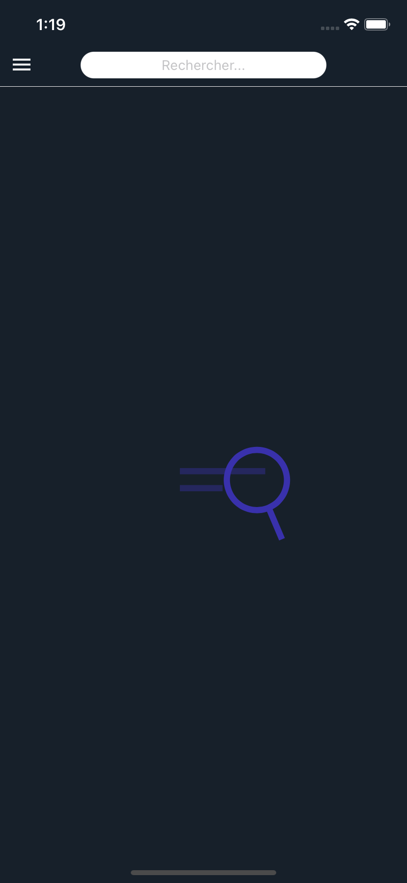

Search screen: You can do a keyword search on Imgur via the search bar.

Profile screen: On the profile screen, you can find your posts, favorites, comments and some information.

Comments screen: On the comments screen, you can also delete your comments, just slide to the right to delete on comment.

Translations: All the application is translated into French and English. You just have to change the language of your phone.

